Name: _______________________________ Date: ___________________
Relations and Functions
Tell whether each is a function or not. Write yes or no.

x | y
0 | 9
-8 | 3
2 | -6
1 | 4
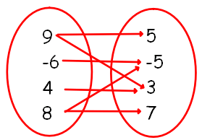

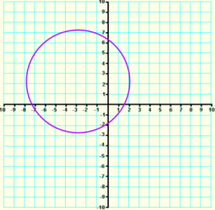

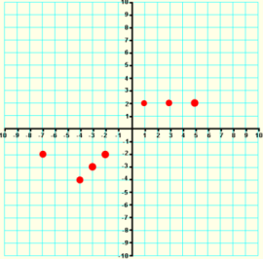

Write the domain and the range of the following relations. Then identify whether it is a function or not (Yes or No).
- $\{(3, 12), (-3, -17), (2, -8), (-1, 7), (6, -8)\}$ _____________________

D: ___________________________________ R: _______________________________

- $\{(-1, 1), (-2, -2.5), (-1, -1.5), (0, 0.5), (-2, 1)\}$ _____________________

D: ___________________________________ R: _______________________________

- Earth moves at a rate of 30 kilometers per second around the Sun. The equation $d = 30t$ relates the distance d in kilometers Earth moves to time t in seconds.
  - Find the range when the domain is $t=\{10, 20, 30, 45, 70\}$.

  - What is the distance traveled by the sun after 120 seconds?

  - How many seconds will it take for the sun to travel 540 kilometers?

- Evaluate the function $f\left(x\right)=2x^{2}-3x+10$, for $f(3)$ and $f(-2).$

Find the range of the following given its domain. Show your work. Make a table for your answers. For numbers 9 and 14, show your work on the space.
- $y = -4x + 5$
x | $$y = -4x + 5$$ | (x, y)
-3
-2
0
1
5

- $f(x)=\frac{1}{2}x- 3$
 | $$f(x)=\frac{1}{2}x- 3$$ | (x, y)
f(-6)
f(-4)
f(-2)
f(0)
f(4)

- $g(x)=-\frac{4}{5}x+1$
 | $$g(x)=-\frac{4}{5}x+1$$ | (x, y)
g(-10)
g(-5)
g(0)
g(5)
g(10)
- $y=x^{2}+ 2$
x | $$y=x^{2}+ 2$$ | (x, y)
-3
-2
-1
1
2

- $y=-x^{2} -3$
x | $$y=-x^{2} -3$$ | (x, y)
-5
-2
0
2
3

- $h\left(x\right)={(3)2}^{x}-5$
 | $$h\left(x\right)={(3)2}^{x}-5$$ | (x, y)
h(0)
h(1)
h(2)
h(3)
h(4)

