**Name: __________________________________ Date: ______________**

**The Faces of Algebra**

**Identify the key features of each graph. Write none if it does not have any.**

|  |  |
| --- | --- |
| 1. . | Function Type: _________________  x – intercept/s: _________________  y – intercept/s: _________________  slope: ________________________  vertex: _______________________  maximum or minimum: ____________  axis of symmetry: _______________  “*a*” value: _____________________  Growth or decay: ________________  Value of *y* when *x =* 1: _____________  asymptote: ____________________ |
| 1. . | Function Type: __________________  x – intercept/s: _________________  y – intercept/s: _________________  slope: ________________________  vertex: _______________________  maximum or minimum: ____________  axis of symmetry: _______________  “*a*” value: _____________________  Growth or decay: ________________  Value of *y* when *x =* 1: _____________  asymptote: ____________________ |
|  | Function Type: __________________  x – intercept/s: _________________  y – intercept/s: _________________  slope: ________________________  vertex: _______________________  maximum or minimum: ____________  axis of symmetry: _______________  “*a*” value: _____________________  Growth or decay: ________________  Value of *y* when *x =* 1: _____________  asymptote: ____________________ |
| 1. . | Function Type: __________________  x – intercept/s: _________________  y – intercept/s: _________________  slope: ________________________  vertex: _______________________  maximum or minimum: ____________  axis of symmetry: _______________  “*a*” value: _____________________  Growth or decay: ________________  Value of *y* when *x =* 1: _____________  asymptote: ____________________ |
| 1. . | Function Type: __________________  x – intercept/s: _________________  y – intercept/s: _________________  slope: ________________________  vertex: _______________________  maximum or minimum: ____________  axis of symmetry: _______________  “*a*” value: _____________________  Growth or decay: ________________  Value of *y* when *x =* 1: _____________  asymptote: ____________________ |
| 1. . | Function Type: __________________  x – intercept/s: _________________  y – intercept/s: _________________  slope: ________________________  vertex: _______________________  maximum or minimum: ____________  axis of symmetry: _______________  “*a*” value: _____________________  Growth or decay: ________________  Value of *y* when *x =* 1: _____________  asymptote: ____________________ |

For each graph, answer the following:

|  |  |
| --- | --- |
| 1. .The graph below shows the height of a toy rocket that is lauched into the air.     Height (feet)  Time (seconds)  What function type is this?  How high is the rocket after 2 seconds? | How high is the rocket after 0.2 second?  What is the maximum height the rocket reach?  How long did it take for the rocket to reach the maximum height?  Approximately how long did it take for the rocket to go back to the ground?  How high was the rocket before it was launched? |
| 1. The graph below represents the number of bacteria in an unfrozen meat.     Time (seconds)  Number of Bacteria | What function type is this?  What is the y-intercept?  What does the y-intercept means based on the graph?  How many bacteria in the meat after a second?  How many bacteria will be in the meat after 2 seconds?  How many bacteria were there in 3 seconds?  If there are 16 bacteria in the meat, how many seconds have passed?  How many bacteria will be in the meat after 4 seconds? |
| 1. The graph below represents the amount of Madyson’s money in the bank.     Amount of Money ($)  Time (years) | What is the y-intercept?  What does the y-intercept mean based on the context of the problem?  What can you say about the Madyson’s money as the year passes?  How much money does she have after3 years?  How much money does she have after 8 years?  How long will it take before Madyson’s account is empty? |

1. A **quadratic function** is a function that can be written in the **standard form**:

*y* = *ax*² + *bx* + *c*

2. Every quadratic function has a U-shaped graph called a __________________________.

3. If the leading coefficient *a* is positive, the parabola ______________________________.

4. If the leading coefficient *a* is negative, the parabola _____________________________.

5. The _______________ is the lowest point of a parabola that opens up and the highest point of a parabola that opens down.

6. The line passing through the vertex that divides the parabola into two symmetric parts is called the ____________________________________________.

7. Solutions of quadratic functions can also be called the ______________________, _______________________, or _______________________.

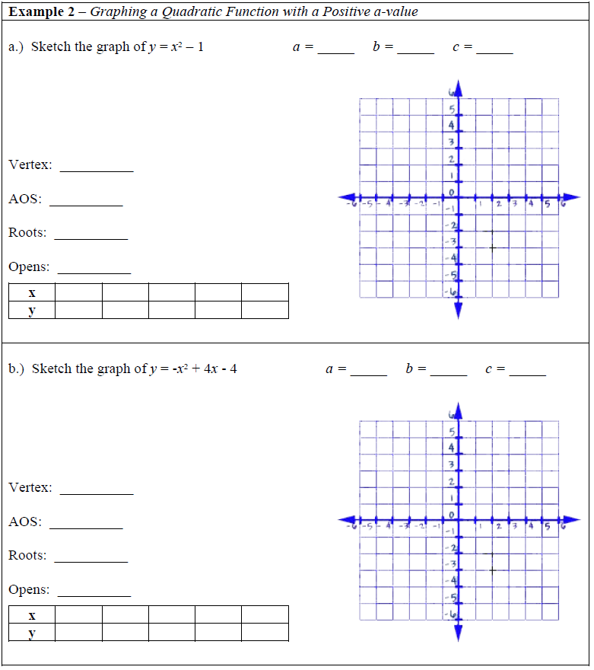

1. 

Function Type:

Asymptote:

Y-intercept:

When x = 1, y = ____

Growth or Decay?

2. 

Function Type:

Asymptote:

Y-intercept:

When x = 1, y = ____

When x = 2, y = ____

When x = 3, y = ____

When x = 4, y = ____

Growth or Decay?