Name: ________________________________ Date: ________________
Graphing Linear Inequalities
Graph each inequality. Make sure the points in your boundary line are correct.

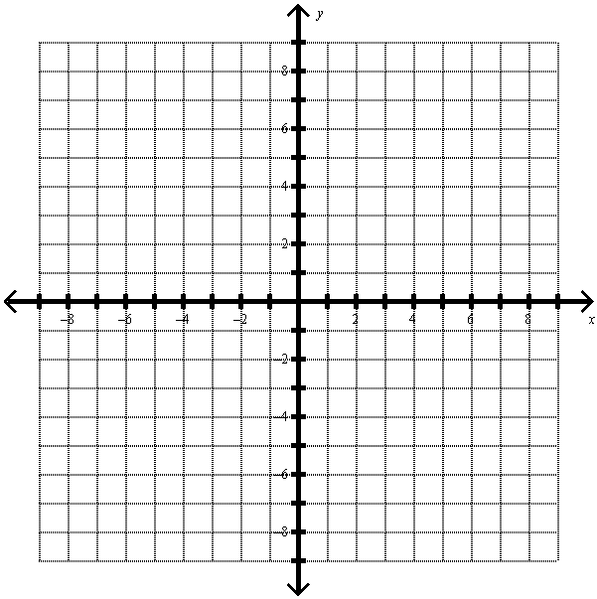
- $y >\frac{2}{3}x-1$
- $4x-3y≤12$
- $y≥-\frac{1}{2}x-4$
- $y<\frac{1}{3}x-3$
- $y≤3$
- $x>-2$

Identify whether the given point is a solution of the given inequality. Write YES or NO.

- $2x + 3y>9;\left(-3, 5\right)$
- $y>\frac{1}{4}x+6;\left(-10, 5\right)$
- $4x-5y≤-35;\left(-8, 6\right)$
- $y≤-2x-3;(-5, 7)$

- You have a $25 calling card. Calls made using the card within the United States cost $0.10 per minutes while calls made from US to France cost $0.25 per minute.
  - Write an inequality that relates the number of minutes x you can use for calls within U.S. and the number of minutes y you can use for calls from the U.S. to France.

  - If you used the card for two hours calling your friend in California, write an inequality to represent the number of minutes you can use the card for calling your friend in Paris, France.

- A salesperson sells two models of vacuum cleaners. One brand sells for $150 each and the other sells for $200 each. The salesperson has a weekly sales goal of at least $1800.
  - Write an inequality relating the revenue from the vacuum cleaners to the sales goal.

  - If the sales person sold exactly six $200 models last week, how many $150 models did she have to sell to make her sales goal?

Write an inequality for each graph. The equation for the boundary line is given.

- $y=2x+4$
- $y=-\frac{2}{3}x-2$
- $y=\frac{1}{3}x-3$

