**Name: ________________________________ Date: _______________**

**Quiz: Quadratic Function**

**Find the vertex for each quadratic function.**

$f\left(x\right)=x^{2}+4$

$f\left(x\right)=-x^{2}+2x-5$

$\left(x\right)=\frac{1}{2}x^{2}-3x+\frac{11}{2}$

$f\left(x\right)=-x^{2}-6x-11$

**Identify whether the given quadratic function has a minimum or a maximum.**

$f\left(x\right)=x^{2}+4x+2$

$f\left(x\right)=-6x^{2}-12x+5$

**Find the equation of the axis of symmetry for the graph of each quadratic function.**

$f\left(x\right)=x^{2}+4x+2$

$f\left(x\right)=-6x^{2}-12x+5$

1. Circle which one is WIDER:



$f\left(x\right)=2x^{2}-1$

$f\left(x\right)=4x^{2}-1$

**Find the y-intercept for the following parabola. Write your answers as ordered pairs.**

$f\left(x\right)=(x+3)^{2}-5$

$y=5x^{2}+10x+8$

$y=\left(x-5\right)\left(x+2\right)$

$f\left(x\right)={-3x}^{2}+7x-13$

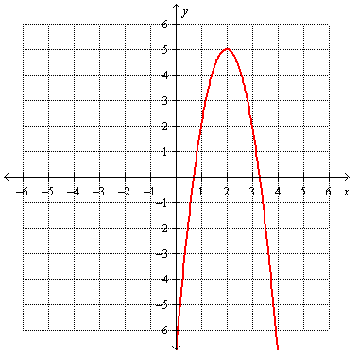**Find the vertex, Axis of Symmetry and identify whether it is a maximum or a minimum.**

Vertex: ___________________________

Axis of Symmetry: __________________

Maximum or minimum: ______________

Vertex: ___________________________

Axis of Symmetry: __________________

Maximum or minimum: ______________

1. 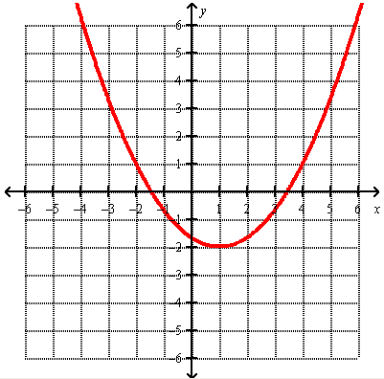.

**Make a table then graph each equation. Remember, you need the vertex first!**

|  |  |  |  |  |  |
| --- | --- | --- | --- | --- | --- |
| **x** |  |  |  |  |  |
| **y** |  |  |  |  |  |



|  |  |  |  |  |  |
| --- | --- | --- | --- | --- | --- |
| **x** |  |  |  |  |  |
| **y** |  |  |  |  |  |

$y=-x^{2}+6x-2$

1. 