Solubility Curves Practice Name_______________
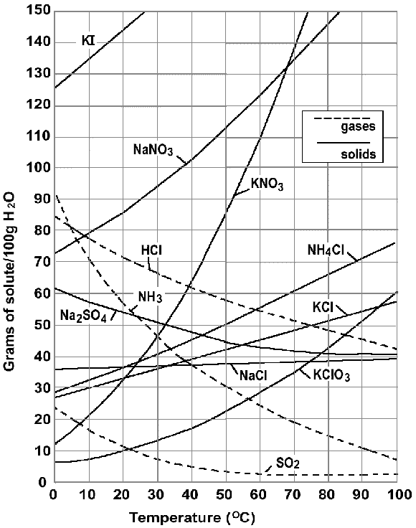
- Which compound is most soluble at 20 Celsius?
- Which compound is least soluble at 10 Celsius?
- Which compound is least soluble at 80 Celsius?
- A salt is a general term for an ionic compound. What is the least soluble salt at 40 Celsius?
- What happens to the solubility of solids as temperature increase?
- What is an unsaturated solution?
- What happens to the solubility of gases as temperature increases?
- Which compound is most soluble at any temperature?
- What is a supersaturated solution?
- How would you describe a solution of 20g of NH4Cl in 100g of water at 70 Celsius?
- How would you describe a solution of 110g of KNO3 in 100g of water at 60 Celsius?
- What is the solubility of hydrochloric acid at 40 Celsius in 50g of water?
- How many grams of NH4Cl would precipitate out if a saturated solution at 90 Celsius was cooled to 50 Celsius?
- How would you describe a solution of 110g of sodium nitrate at 40 Celsius in 100g of water?
- How would you describe a solution of 110g of sodium nitrate at 40 Celsius in 200g of water?
- What is the solubility (saturation point) of KClO3 at 20 Celsius in 100g of water?
- Which compound shows the smallest change in solubility from 0 to 100 Celsius?
- At what temperature is the solubility of ammonia equal to the solubility of potassium chlorate?

