Reaction Types & Balancing Name_______________

Balance the following equations and indicate the type of reaction taking place:

- ____ NaBr + ____ H₃PO₄ → ____ Na₃PO₄ + ____ HBr

Type of reaction: ____________________

- ____ Ca(OH)₂ + ____ Al₂(SO₄)₃ → ____ CaSO₄ + ____ Al(OH)₃

Type of reaction: ____________________

- ____ Mg + ____ Fe₂O₃ → ____ Fe + ____ MgO

Type of reaction: ____________________

- ____ C₂H₄ + ____ O₂ → ____ CO₂ + ____ H₂O

Type of reaction: ____________________

- ____ NH₃ + ____ I₂ → ____ N₂I₆ + ____ H₂

Type of reaction: ____________________

- ____ H₂SO₄ + ____ NH₄OH → ____ HOH + ____ (NH₄)₂SO₄

Type of reaction: ____________________

- ____ N₂ + ____ H₂ → ____ NH₃

Type of reaction: ____________________

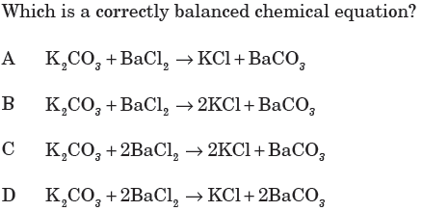
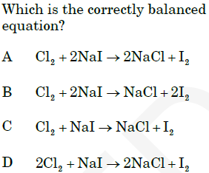

Types of Reactions Worksheet – Solutions

Balance the following equations and indicate the type of reaction taking place:

1) 3 NaBr + 1 H₃PO₄ → 1 Na₃PO₄ + 3 HBr

Type of reaction: double displacement

2) 3 Ca(OH)₂ + 1 Al₂(SO₄)₃ → 3 CaSO₄ + 2 Al(OH)₃

Type of reaction: double displacement

3) 3 Mg + 1 Fe₂O₃ → 2 Fe + 3 MgO

Type of reaction: single displacement

4) 1 C₂H₄ + 3 O₂ → 2 CO₂ + 2 H₂O

Type of reaction: combustion

5) 2 PbSO₄ → 2 PbSO₃ + 1 O₂

Type of reaction: decomposition

6) 2 NH₃ + 3 I₂ → 1 N₂I₆ + 3 H₂

Type of reaction: double displacement

7) 1 H₂O + 1 SO₃ → 1 H₂SO₄

Type of reaction: decomposition

8) 1 H₂SO₄ + 2 NH₄OH → 2 H₂O + 1 (NH₄)₂SO₄

Type of reaction: acid-base

