Solubility Curves Quiz
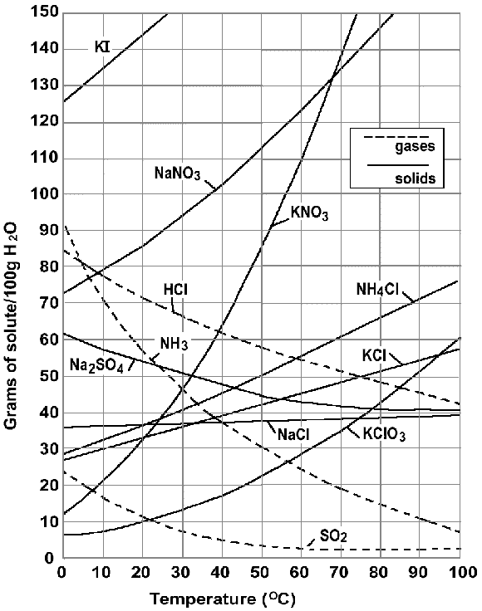
- Which compound is least soluble at 10 Celsius?
- What happens to the solubility of solids as temperature increase?
- Define a saturated solution?
- How would you describe a solution of 20g of NH4Cl in 100g of water at 70 Celsius?
- How would you describe a solution of 110g of KNO3 in 100g of water at 60 Celsius?
- What is the solubility of hydrochloric acid at 40 Celsius in 50g of water?
- How would you describe a solution of 110g of sodium nitrate at 40 Celsius in 100g of water?
- What is the solubility (saturation point) of KClO3 at 20 Celsius in 100g of water?
- Which compound shows the smallest change in solubility from 0 to 100 Celsius?
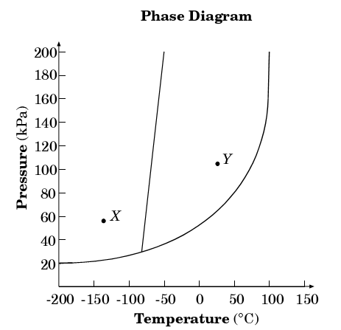
- At what temperature is the solubility of ammonia equal to the solubility of potassium chlorate?
11. What phase is the substance at point Y?
a. solid b. liquid
c. gas d. plasma

12. What is the normal boiling point?
a. -78 b. 70
c. 101 d. 0

13. At what pressure do all three states exist?
a. 25 b. 1
c. 200 d. 140

14. What change in state would occur as you moved from point X to point Y?
a.melting b. boiling
c. sublimation d. freezing

