Nuclear Decay Review NAME_______________________

Write the equations for the following processes:
1) The alpha decay of radon-198

2) The beta decay of uranium -237

3) The alpha and gamma decay of carbon-14

Which type of radiation is most penetrating?

What type of radiation could metal foil block?

What is needed to block gamma radiation?

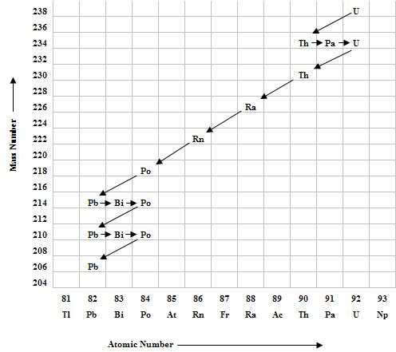
As Uranium decays from Th to Ra, what type of decay is occurring?

As Uranium decays from Bi to Po, what type of decay is occurring?

When on the graph are gamma rays being emitted?

When beta decay occurs, the atomic number increases by one. Explain what process causes this to happen. Include the basic equation that illustrates this process.
What is the mass of an alpha particle?

What is the charge of an alpha particle?

What is the charge of a beta particle?

What is the mass of a gamma ray?

How could you control the rate of nuclear decay?

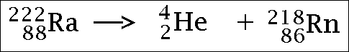
What type of decay is shown above?

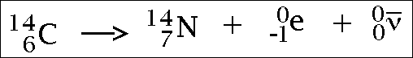
What type of decay is shown above?

During gamma decay, which of the following change:
Atomic Number (yes) (no)
Mass Number (yes) (no)

During alpha decay which of the following change:
Atomic Number (yes) (no)
Mass Number (yes) (no)

During beta decay which of the following change:
Atomic Number (yes) (no)
Mass Number (yes) (no)

