Goal 4.02

In a closed system, energy is neither ________ nor _____________, but can be _____________ from one form to another.

The total useful energy of an open system is always ________________ due to ________________.

Define:
Enthalpy-

Entropy-

Specific heat capacity-

Temperature-

Joule-

Endothermic reaction (w/ examples)-

Exothermic reaction (w/ examples)-

Catalyst (and tell how it does what it does)-

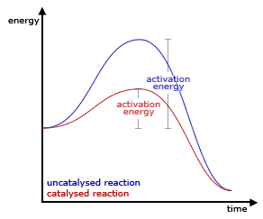
Be sure you understand this diagram.
(Effect of catalyst, activation energy, reactant side, product side)

Be sure you could label EXACTLY activation energy.

Is this an exothermic or endothermic reaction?

Contrast heat and temperature:

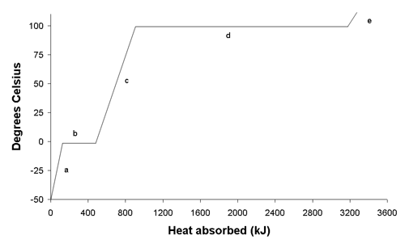
Label the relevant parts.

Where is Potential Energy changing?

Where is kinetic energy changing?

What is the freezing point?

What is the melting point?

At what point would some of the material be liquid and some gas?

The above diagram is called a heating curve. Draw and label a cooling curve.

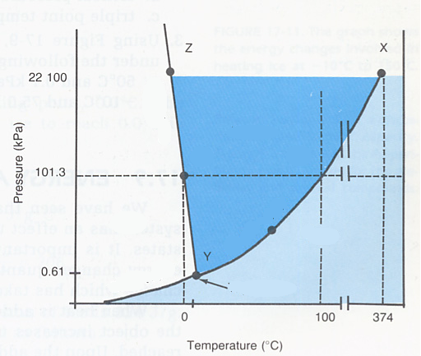
This is called a _____________________

Label the relevant parts.

What substance is this for?

If you move from 50 to -50 at standard pressure what change has occurred?

Moving from 0.5 to 100kPa at 50C what change occurs?

Describe the conditions at point Y.

Describe the conditions at point X?

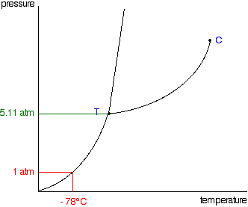
This is a phase diagram for carbon dioxide.

What is interesting about the change in state it undergoes at standard pressure according to the diagram?

At what sort of conditions could you have liquid carbon dioxide? (You may answer qualitatively.)

Goal 4.03

Entropy is a measure of disorder.

Increasing Entropy: solid → liquid → gas
Ionic Compounds → Ions in solution

The entropy of the universe is always _____________.

Systems tend to move towards the lowest energy level and in the direction of greatest entropy.

Goal 4.04

Describe the penetrating power of the 3 types of radiation:
1.

2.

3.

Write the symbol for an alpha particle:

Write the symbol for a beta particle:

Write the symbol for gamma radiation:

What type of radiation results in a change in mass # and atomic number?

U-238 undergoes beta decay, what atom results?

True or False: There is no way to control the rate of nuclear decay.

Contrast Fission and Fusion:

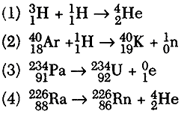
Which equation above represents beta decay?

Which represents alpha decay?

Which represents fusion?

What does the above equation represent?

What is the mass of an alpha particle?

What is the charge of an alpha particle?

List 3 uses of nuclear chemistry:

1. An isotope of cesium (cesium-137) has a half-life of 30 years. If 1.0 mg of cesium-137 disintegrates over a period of 90 years, how many mg of cesium-137 would remain?

2. A 2.5 gram sample of an isotope of strontium-90 was formed in a 1960 explosion of an atomic bomb at Johnson Island in the Pacific Test Site. The half-life of strontium-90 is 28 years. In what year will only 0.625 grams of this strontium-90 remain?

3. Actinium-226 has a half-life of 29 hours. If 100 mg of actinium-226 disintegrates over a period of 58 hours, how many mg of actinium-226 will remain?

4. The half-life of isotope X is 2.0 years. How many years would it take for a 4.0 mg sample of X to decay and have only 0.50 mg of it remain?

5. After 3 half-lives have passed, 0.375 grams of Bismuth-218remain. How big was the original sample?

6. The half-life of a radioactive element is 30 seconds. In what period of time would the activity of the sample be reduced to one-sixteenth of the original activity?

- The half-life of francium is 3 minutes. After 18 minutes, what fraction of the original sample remains?
Thermochemistry Problems
1. How much energy must be absorbed by 20.0 g of water to increase its temperature from 283.0 °C to 303.0 °C?
2. When 15.0 g of steam drops in temperature from 275.0 °C to 250.0 °C, how much heat energy is released?
3. How much energy is needed to melt 150g of ice?
4. How much energy is required to heat 120.0 g of water from 2.0 °C to 24.0 °C?
5. If 720.0 g of steam at 400.0 °C absorbs 800.0 kJ of heat energy, what will be its increase in temperature?
6. How much energy is needed to boil 75g of water?
7. How much heat (in kJ) is given out when 85.0 g of lead cools from 200.0 °C to 10.0 °C?
8. If it takes 41.72 joules to heat a piece of gold weighing 18.69 g from 10.0 °C to 27.0 °C, what is the specific heat of the gold?
9. It takes 333.51 joules to melt exactly 1 gram of a substance. What is the molar heat of fusion for water, from this data?
10. What mass of water can be melted using 800J of heat?

