Chemistry EOC Review Goals 2.07-3.01
Goal 2.07
Atoms share electrons to become more like _________ _________
True or False: Atoms bond to become more stable.
Atoms form a mostly covalent bond if they have a _________ difference in electronegativity.
A _______________ compound is one that contains covalent bonds.
List the 7 diatomic molecules.
What type of bond exists in an N₂ molecule? ______________ ______________
Name a diatomic that forms a double covalent bond.
Name a diatomic that forms a single covalent bond.
(Remember, to determine number of bonds, count VE’s, determine how many more are needed to make 8 [or 2 if it it Hydrogen] and that is the number of covalent bonds needed.)
Covalent bonding occurs between a ___________ and a _____________.
Which compound has the longest bond, HF or HCl?
Which of the above compounds has the stronger bond?
Draw a Lewis Structure for Lithium, Neon, Sulfur, and Aluminum.

List and draw the 5 VSEPR shapes you are supposed to know.

Explain how bonds affect VSEPR shape versus how unshared pairs do.

Tell the shape of the following molecules:
H₂O
CH₄
NH₃
CO₂
CO
BF₃
Which VSEPR shape as the largest bond angle?
The smallest?
Identify the following as polar or nonpolar:
H₂O
NaCl
F₂
HCl
NO₂
CO₂
Water is polar. Substance B will not dissolve in water. Is substance B polar or nonpolar?
What is the general rule for solubility as it relates to polarity?
Networks solids are a special type of molecular (covalent) compound, but possess some very different properties. Describe how a network solid differs from other molecular compounds.

Give an example of a network solid.
What is the strongest type of intermolecular force?
What is the weakest?
Goal 2.08
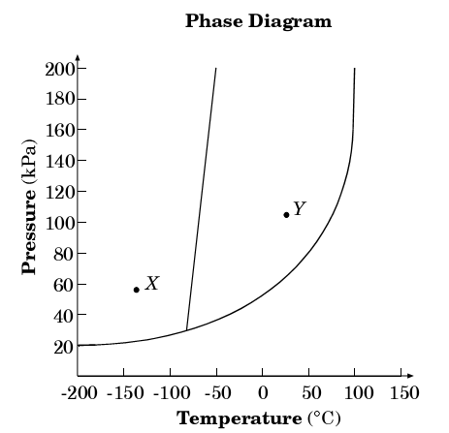
What phase is the substance at point X?
a. solid b. liquid
c. gas d. plasma
What is the normal melting point?
a. -78 b. 60
c. 101 d. 0
At what pressure do all three states exist?
a. 25 b. 1
c. 200 d. 140
What change in state would occur as you moved from point Y to point X?
a.melting b. boiling
c. sublimation d. freezing
After what temperature is the liquid phase indistinguishable from the gas phase? (critical point)
Upon what 2 things does a substances state of matter depend?
Define sublimation:
Goal 3.01
What are the rows in the periodic table called?
What are the columns called?
Give 2 other names for group 7A.
What element is in group 3 period 4?
Name an element with properties similar to Magnesium.
Elements in the same group have the same number of _____________ ______________ and because of this have similar _________________.
Elements in the same period have the same number of ______________ ___________ _____________
What is the most reactive element in group 1A?
What is the most reactive element in group 7A?
Identify the group number for the following:
Inert Gases/Noble Gases
Alkali Metals
Halogens
Alkaline Earth Metals
Transition Metals
Are most of the elements metals or nonmetals?
Name 3 metalloids.
Where is the p block located?
Where is the d block located?
How could you identify an element based on it electron configuration?
Could you still identify the element if you were given the e- config in noble gas shorthand? How?
[Ar] 4s²3d¹⁰4p². Identify this element.
How many valence electrons does the above element have?
[Ar] 4s²3d⁴. How many valence electrons does this element have? What element is it?
What is the oxidation number of Zinc?
Of Silver? Of Oxygen? Of Calcium? Of Lithium?
Write the electron configuration for Oxygen and Silicon.
Write the electron config using noble has shorthand for Iodine, Vandium, and Sulfur.
Draw the orbital diagram for oxygen and silicon.

Define Ionization Energy:
Why does IE decrease as you move down a group?

Which has a higher IE? O or F? Cl or Br? Ag or As? Cs or Ca?
Define Electronegativity:
Why does EN increase as you move across a period?

Which has a higher EN? O or F? Cl or Br? Ag or As? Cs or Ca?
Which has a bigger radius? O or F? Cl or Br? Ag or As? Cs or Ca?
Which has a bigger or radius? O or O²⁻ K or K⁺ Mg or Mg²⁺ Br or Br⁻?
Which has a smaller radius, a cation or the atom it forms from? Explain Why.
A compound is polar if it contains Covalent bonds and the atoms involved have different _________________ values.

