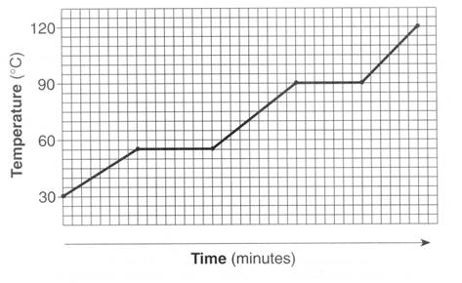

Hf=250

Hv=2000

Cp=3.0

What is the freezing point of the above substance?

What is the melting point?

What is the vaporization point?

Define Temperature:

When is the potential energy of the above substance changing?

How much energy was added to the substance above between t=0 and when it began to melt, assuming a 5g sample?

Answer the same question above, assuming a 10g sample.

How much energy would be required to vaporize 25g of the above substance?

How much energy would be required to vaporize 75g of the above substance?

How much energy would be released if 100g of the above substance were to freeze?

Would that process be endothermic or exothermic?

How much energy was consumed during the time this substance was a liquid, assuming a 700g sample?

How long did it take to melt the substance?

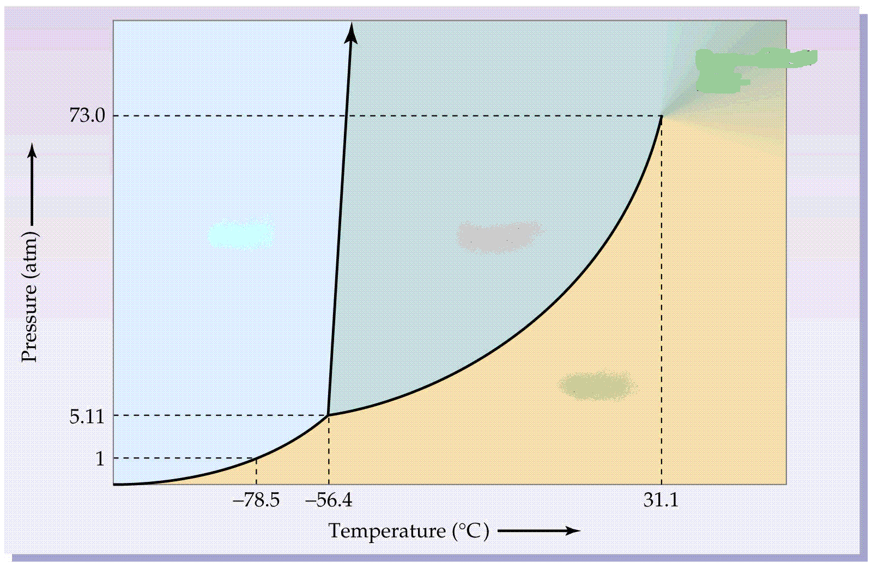

Is the above phase diagram for water?

Upon what 2 things does the state of an object depend?

Define Critical Point:

What is the critical point for this substance?

Define Triple Point:

What is the triple point of this substance?

At 70 atm, a piece of this substance is heated from 0 to 50 degrees Celsius, what change has it undergone?

At 1 atm, a piece of this substance is heated from -100 to -60 degrees Celsius, what change has it undergone?

At 0 degrees celsius, a piece of this substance is undergoes a change in pressure from 1 to 60 atm. What change has it undergone?

At 73atm, a piece of this substance is cooled from 20 to -200 degrees Celsius, what change has it undergone?

