VSEPR, EN, IE, Radii Quiz
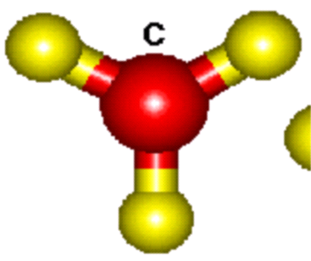
- What shape is depicted to the left?
- What does VSEPR Theory stand for?
- What is the shape of a CH₄ molecule?
- What is the shape of an H₂O molecule?
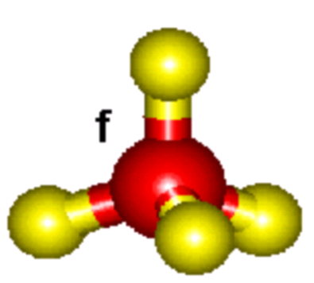
- What is the shape of an NH₃ molecule?
- What shape is depicted to the right?
- Which is larger, a magnesium atom or a magnesium ion?
- Which has a longer bond length, HF or HCl?
- Which is shorter, a double or triple covalent bond?
- Which has a higher electronegativity, Calcium or Barium?
- Which bond is stronger, HBr or HI?
- Which has a larger radius, phosphorus or oxygen?
- Which has a lower first ionization energy, carbon or nitrogen?
- Define electronegativity.
- Which has a smaller bond angle, a linear molecule or a pyramidal molecule?

